How to use SPIP as an author
The objective of this course is to teach how to use SPIP as an author. It requires no previous computer science knowledge. You just need to know how to surf on internet and web sites.

Introduction
SPIP is a Content Management System (CMS). It permits to manage automatically a website with a team of persons without requiring the help of a webmaster for updates.
SPIP is free software, distributed under the GNU/GPL licence. SPIP is free. The version 2.0 of SPIP was issued on December 2008. You can download a complete version and documentation : http://www.spip.net

Architecture of a SPIP website
A SPIP website is always composed of two parts:

A public part
As its name suggests, this part it is what you see when surfing on the web. You will find all usual functions of a website: sections, articles, brief notes, forums and chat areas. You can see the site, but not modify it.
Example public part : http://www.mywebsite.org

Private part
The private part, also called back-office, is where you modify the site and the content. Only administrators and authors of the site can access it. To enter the private part you just need to add /ecrire/ after the website’s name.
Example private part : http://www.mywebsite.org/ecrire/
On this page you are asked to enter you login and password, which your administrator has given you (some websites allow free entry to the private part as authors).
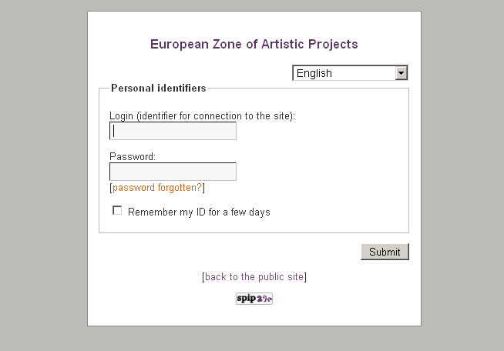
Identification page accessible at the adress : http://www.mywebsite.org/ecrire/
Once accepted you are in front of the interface that allows you to modify the content of the website.
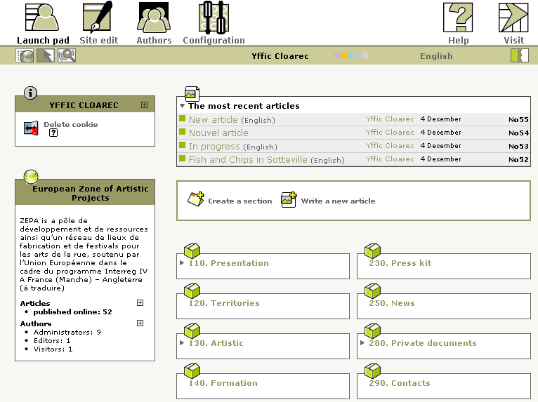
Private part of SPIP (backoffice)

Write your first article

Step 1 : Choose the section where you want to write your article
Go to the menu Launch Pad  Choose the section where you want to write your article, | 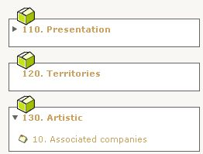
and then click on the icon Write a new article | 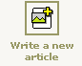

Step 2 : Complete the editing form of the article
Now you are in a webpage where you can write and modify your article. Complete the different areas: Title, Deck (introductory part of your article), Text. Then click on Submit button, under the text.

Step 3 : Request the publication of your article
Once your article is modified, you can request to publish it, in order to have it appear in the public part of the website | 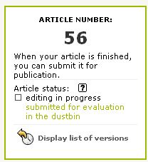

Your article will then be sent to the administrator of the website who will decide to publish it or not. It is a human that validates the articles, so that may take some time!
If you want to see the status of this validation phase go to the menu Launch pad
As long as your article is not validated, you can modify it.
Tip : You can see the status of an article by the small icons at the side of the article. | 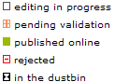

Step 4 : Validation of your article by an administrator
If one of the administrators publishes your article, you can consult it on-line by clicking on View online | 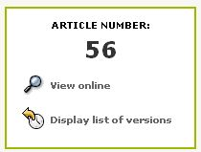

Caution : For security reasons, once validated, you can't modify your article anymore. If you need to modify this article, you have to ask an administrator to change its status to submitted for evaluation

Write a complete article

Use the typographical enhancements
In order to maintain a coherent website, you cannot modify all aspects of the article you write as in a classic word processor. The important is to divide your text in parts (title, paragraph, lists...). The choice of characters and the size of letters have been chosen by the technical team of the website.
But you can enrich the typography of your text
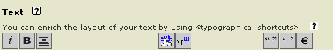
To use this toolbar, select the text you want to enhance and click a button (italic, bold, title, hypertext link,...). A code will appear then around the selected text.
Example code | Displayed result
Alice meets {{bob}} | Alice meets bob

This code is named a typographical enhacement shortcut.
See annex the typo enhancements
Caution : The text in the private site is not exactly the same as in your public site. In some SPIP site you can preview the article so that you see how it will appear on the website.
Note : For those who are confirmed web users, you can also type directly HTML code. (not recommended).

HTML restrictions : blank spaces et carriage returns
Spip articles are displayed in a web language : the HTML, which presents some peculiarities and limitations
Blank spaces
Blank spaces are not taken into account and the effects of tabulations, margins are simply ignored
Example code | Displayed result
cat and dog | Cat and dog

Carriage returns
Simple carriage returns are ignored
Example code | Displayed result
cat  and  dog | cat and dog

Double carriage returns (press twice on Entry) allow to create a paragraph
To make a simple carriage return, use the shortcut _ (in the begining of the line) with a space after
Example code | Displayed result
cat  _ and  _ dog | cat  and  dog

Add an external link
Example code | Displayed result
[link to google->http://www.google.com] | Link to google
[->http://www.google.com] | http://www.google.gom
Caution : don't forget to type complete adresses which always begin by http://...

Add an internal link
An internal link is a link which points to another object of the site and facilitates the navigation of the Internet user
To create an internal link, it is necessary to know the article number
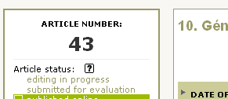
Each SPIP object has a number
(A section in French is called a “rubrique”, therefore the instruction is rub5 for section 5, rub6 for section 6 and so on)
The shortcut to make the link to this article is : [consult article->4]
Tip : It's possible to omit the left expression : [->4]. In that case SPIP shows the title of the targeted object
Memo | Syntax
Link to an article | [text of the link->43]
Link to a section | [text of the link-->rub43]
Link to an author | [text of the link-->aut43]
Link to a news | [text of the link-->br43]

Add images and documents inside articles

Step 1 : Prepare your documents for Web
It is important to prepare in advance your documents on your computer before publishing them, so that all the Internet users can consult them easily. Here are some points to verify :
- The weight of documents : not to exceed 1 Mb (méga byte), generally your document should weigh 200 in 300 Kb at most
- The format of documents : use usual formats (pdf, txt, zip...), avoid proprietary or potentially hazardous formats (doc, exe, …). For images, choose the Web formats : jpg (photos) and png or gif (logos, illustrations)
- The size of documents : for images, the resolution has to be 72 dpi in mode RVB (Red Green Blue) and we suggest not to exceed a width of 800px by image

Step 2 : Add documents inside article
Modify the article | 
Use the form of download  if your document is heavy, the download can take time | 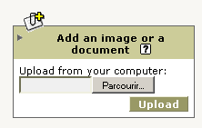

If your document is an image  A small icon of the image appears | If your document is a file,  A small icon of the document appears
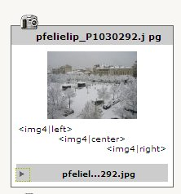 | 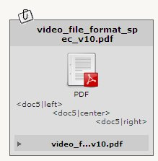
Complete the information  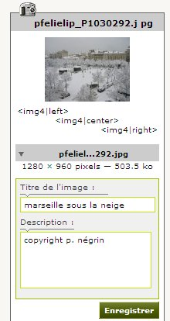 | 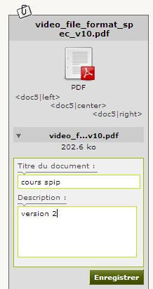
Insert the document into the text of the article via its shortcut
<img4> | <doc5>

To add several documents at one time
To spare time, it is possible to add several documents at one time
- On your computer, group together your documents in a zip file (verify that your file does not exceed the limit size authorised by the site)
- Use the usual form to add documents
- Choose the option decompressed and every element it contains

Add voluminous documents
Every site possesses a limit size (which varies from 2Mo to several megas) for sending of documents. If your document exceeds this limit, contact the administrator of the site to add himself the document in FTP or use the option « reference an external document on internet »

Manage the images of the portfolio
SPIP distinguishes two types of images :
- The images which serve to illustrate the text of the thanks to the usual shorcuts <img>, <doc>
- The images of the portfolio to create automatically an album photo (no shortcut to be added)

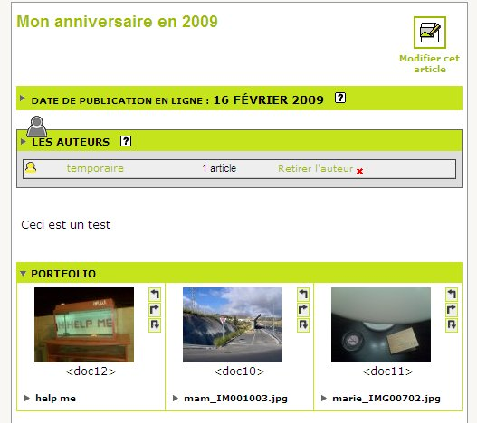
The portfolio appears at the bottom of the article

To add the images in the portfolio,  it is necessary to add them with the form add a document | 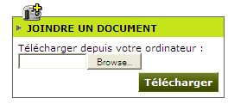
If your image was placed on the server as an image, you can put it in the portfolio by unfolding the information of image and by clicking the button « to put down this image in the portfolio » | 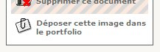

Use plugins
Plugins are additional modules which add features to the site SPIP. These plugins are installed by the administrators of the site.
Here are some frequently installed plugins :
- Pencils direct publishing from the public interface
- Diary management of a calendar and events
- Multimedia reader mp3 reader and video flash
To know more about plugins and their instructions for use, consult http://www.spip-contrib.net and http://plugins.spip.net

Various tips

Add keywords
On certain websites you can add keywords that allow to order and classify articles
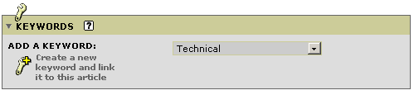

How to move an article ?
Publish the article and modify the field In section
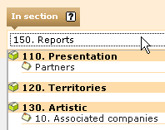

How to add a video or a piece of music?
If your video is accommodated on an external site like dailymotion, YouTube, stick the HTML code of the video to integrate it into your article
Otherwise, you have to prepare the video for the format flash (.flv ) or your piece of music in the format (.mp3 44.000 Hz). Add the file in your article as document. Caution : on the site must be installed a plugin allowing the reading of this type of file (as plugin multimedia reader or XSPF)

Use many languages
If your site uses only one language you can skip this section.
In most multilingual websites, we create a principal section for each language. Each main language (French, English Arabic, … ) functions as a small site inside the main website.) Then comes a system of translation links that permit to associate an article and its translation. This translation is not automatic, you have to write it (or a translator has to do the work).

Translate an article
Go to the article you want to translate and unroll the thumbnail Article language and translations.
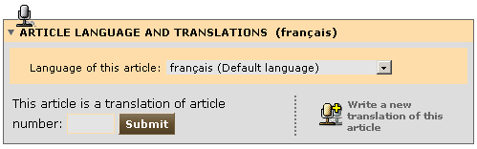
A page with all the spaces of an article is opened where you can write your translation. Do not forget to locate the article inside the correct language section of the website. After you have validated your translation, in the language box you should have a link between the two articles, the original article and the translation.
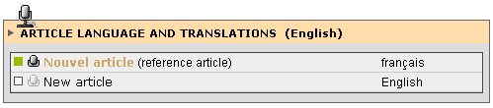
You now have a new article (the translation) which you have to ask to be published as any other article.
Caution : Documents attached to the article are not translated. It is thus necessary to translate them manually. On the other hand, the so-called code of the images <imgNN> remains valid, you don't have to modify it.

More information…
In the private part you have a complete help system. Use it and read it. Click on the icons which supply a contextual help
If you want to know more about it and to complete your knowledge on SPIP
http://www.spip.net/fr The official site of SPIP (in French)
http://www.spip.net/en The official site of SPIP (in English)
http://www.spip-contrib.net/lang=en Site of resources on SPIP
If you want to know more about it and to complete your knowledge on SPIP
Regarding this course
This course is placed under license Creative Commons by-nc-sa :
To read the terms of this license : http://creativecommons.org/licenses/by-nc-sa/2.0/fr/

Please send us your remarks on this manual and suggestion to :
http://www.erational.org
Annex : Shortcuts
Edition  Title  {{{space between the lines}}}  Layout of the text (on-line)  {{bold}}  {italic}  <del>crossed text</del>  <code>code</code>  <math>math expression TeX</math>  Special units  <poesie>line of poetry</poesie>  <cadre>text</cadre>  <quote>quotation</quote>  blank spaces and carriage returns  _ carriage return  ---- delimiter  -- em quad dash  hard~space  To avoid  -first line  -second line  -third line  <html> code | Links  External link  [text->http://www.spip.net/]  [->http://www.spip.net/]  [text|tool tip->http://www.spip.net/]  [?Wikipedia]  Email link  [text->me@me.org]  [->me@me.org]  Internal link  [text->12]  [->12]  [text->rub99]  [->rub99]  [text->aut3]  [->aut3]  [text->br3]  [->br3]  Anchor link  [definition_anchor<-]  [return to anchor->#definition_anchor]  Footnote  text[[automatically numbered note]]  text[[<XX>footnote manually numbered]]
Non textual documents  Image  <imgXXX>  <imgXXX|left>  <imgXXX|center>  <imgXXX|right>  Document to download  <docXXX>  <docXXX|left>  <docXXX|center>  <docXXX|right>  Embedded document  <embXXX>  <embXXX|left>  <embXXX|center>  <embXXX|right> | Lists and Tables  Bulleted list  -* first line  -* second line  -* third line  Numbered list  -# first item  -# second item  -## a numbered ne sub-list  -# back to initial level  Table  ||Column one|Column two||  |{{title a}}|{{title b}}|  |1a|1b|  |2a|2b|  |3a|3c|
i

see SPIP documentation for a list of languages.

